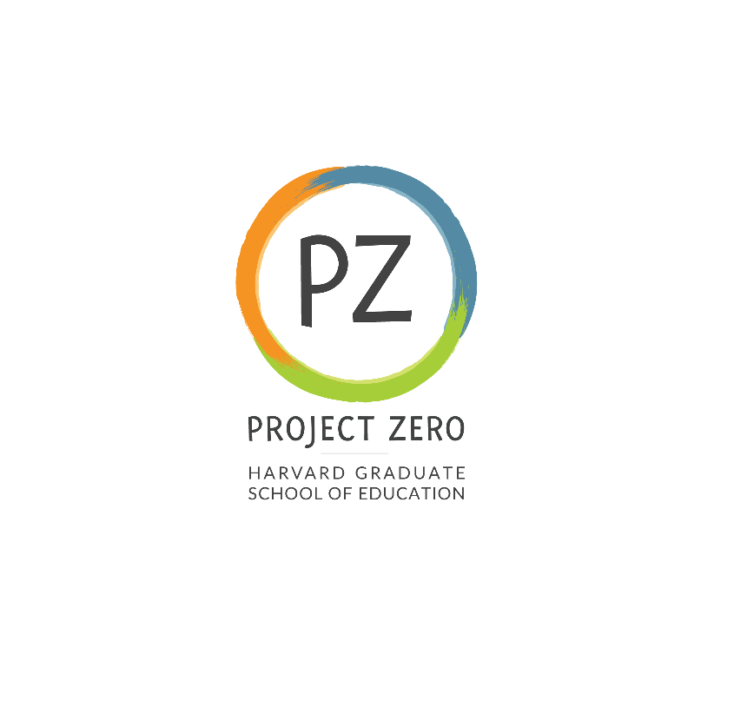

Title: **Research Assistant 1**

**Start date**: September 5, 2023

**End date**: March 8, 2024

**Supervisor:**

Carin Aquiline

**Description:**

Project Zero - Research Assistant, Transformative Repair (TR) project

The **Transformative Repair (TR) project**, based at Project Zero (pz.harvard.edu), investigates how strategic and sustained engagement with transformative repair as a concept and practice can support individuals and communities to:

* address and embrace literal and metaphorical damage in their lives, and
* develop the inclination and ability to repair and transform their communities.

**Responsibilities:**

The project is looking for a graduate student research assistant to:

* review literature to contribute to the research base for the project
* identify topics to add to the literature review
* participate in concept development for the project framework and activities
* contribute to the development of educator resources and written products

The research assistant will also provide light general administrative support for the project as needed.

**Basic and preferred qualifications:**

Basic qualifications:

Candidates should have strong analytic and written communication skills and the ability to manage work and meet deadlines with minimal supervision.

Applicants must reside and be eligible to work in the United States.

Preferred qualifications:

The following qualifications would be helpful in the position but are NOT required:

* experience conducting a literature review
* some familiarity with cognitive science
* knowledge about building a wide social media audience

**Work location**:

Cambridge Campus

**Expected pay rate or range**: Graduate student rates apply (Masters students $22/hr)

**Expected pay frequency**: Weekly

**Expected work schedule**: 7-10 hours/week. Schedule TBD

**Application process:**

Email cover letter and resume to Carin Aquiline, [carin_aquiline@gse.harvard.edu](mailto:carin_aquiline@gse.harvard.edu)

**Deadline for applying:**

Job posting open until filled; applications reviewed on a rolling basis

This position will be included in the Harvard Graduate Student Union (HGSU-UAW) if filled by a Harvard Student.

We are an equal opportunity employer, and all qualified applicants will receive consideration for employment without regard to race, color, religion, sex, national origin, disability status, protected veteran status, gender identity, sexual orientation, pregnancy and pregnancy-related conditions, or any other characteristic protected by law.