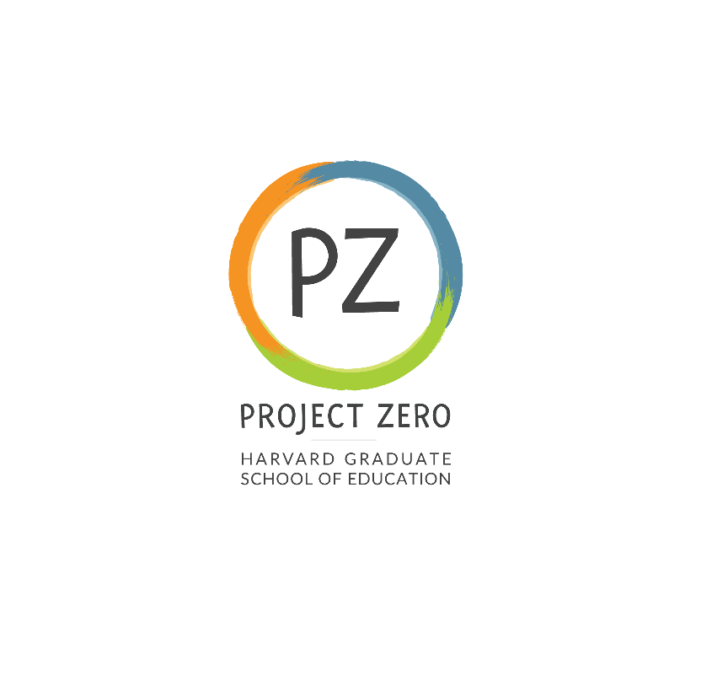

Title: **Research Assistant 1**

**Start date**: 9/13/23

**End date**: 5/23/24

**Supervisor:**

Sarah Alvord, Senior Manager of Special Projects

**Description:**

Project Zero - Research Assistant, Project Zero (PZ) Reach team

**About the project**

Project Zero (PZ) is a research center at the Harvard Graduate School of Education. PZ research, frameworks, and tools are made accessible to educators around the world through its in person and virtual professional education programs. These offerings are scheduled at various times throughout the year, are research-based, and grounded in the day-to-day work of teachers and administrators. The PZ Reach team administers PZ’s professional development opportunities.

**Responsibilities:**

PZ Reach is currently seeking a Research Assistant (RA) for approximately 7-10 hours a week for the full school year (September 2023 – May 2024). The RA will support the PZ Reach team led by Tina Blythe, a senior researcher at PZ, and Sarah Alvord, a senior administrator at PZ.

Research tasks will include analysis of data from workshops, online courses, and conferences. Building in part from the analysis, further work will include the support of PZ’s outreach and communications and marketing research. Support for staffing some of the professional development offerings may be needed as well as additional tasks that arise over the course of the year as new initiatives and requests come in.

Work will be hybrid - both completed at Project Zero (Longfellow Hall, 4th Floor, Appian Way, Cambridge) as well as remotely.

**Basic and preferred qualifications:**

Candidates should have experience and/or interest in basic research skills, project management, organization system building, and data organization; proficiency with MS Suite, Qualtrics, and Google products and familiarity with general project management software needed.

Strength in detail orientation, interpersonal relations, and written/oral communication skills is also required. Knowledge of online learning platforms and the PZ course topics is desirable.

Applicants must reside and be eligible to work in the United States.

**Work location**:

Cambridge Campus

**Expected pay rate or range**:

Undergraduate or Graduate student rates, based on experience; work-study preferred.

**Expected pay frequency**:

Weekly

**Expected work schedule**:

7-10 hours per week. Schedule TBD.

**Application process:**

Please send a brief cover letter and resume by Wednesday, September 6, 2023, to Brooke Martin, PZ Reach Project Assistant: Brooke_Martin@gse.harvard.edu.

**Deadline for applying:**

9/6/23

This position will be included in the Harvard Graduate Student Union (HGSU-UAW) if filled by a Harvard Student.

We are an equal opportunity employer, and all qualified applicants will receive consideration for employment without regard to race, color, religion, sex, national origin, disability status, protected veteran status, gender identity, sexual orientation, pregnancy and pregnancy-related conditions, or any other characteristic protected by law.