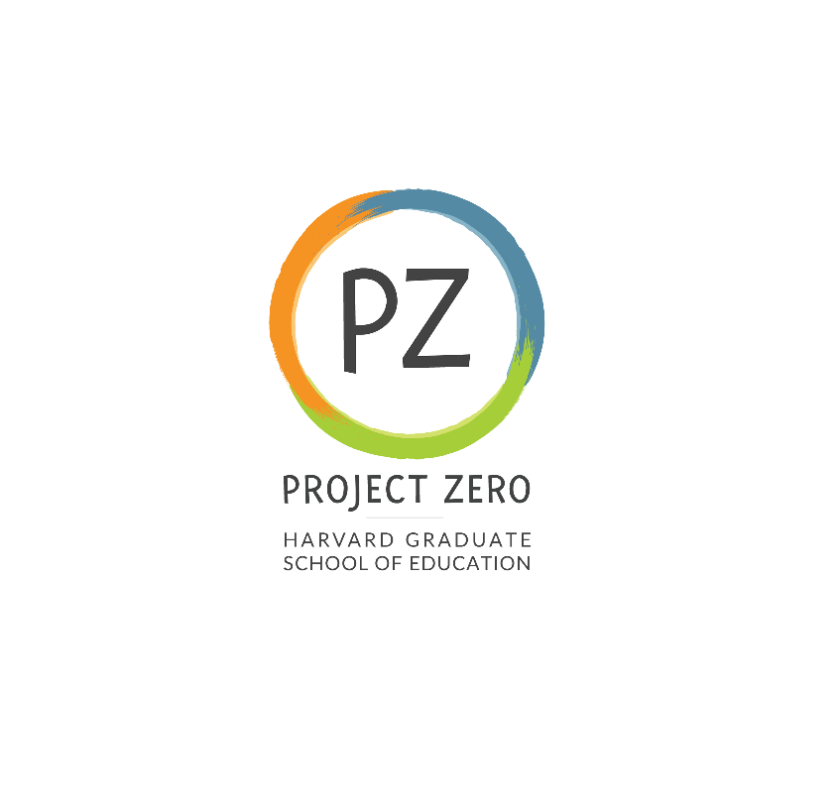

Title: **Research Assistant 1**

**Start date**: September 6, 2023

**End date**: May 23, 2024

**Supervisor:**

Marga Biller, Project Director

**Description:**

Project Zero - Research Assistant (Project Documentation and Social Media Specialist), Learning Innovations Laboratory (LILA)

**Learning Innovations Laboratory (LILA)** at the Harvard Graduate School of Education’s Project Zero is a consortium of leading researchers and practitioners in the field of organizational learning and change. Through creating social connections, crafting insights, and having a practical impact, LILA strives to learn more about today's challenges in the field. LILA is composed of members from three areas: organizational leaders from private, public, and non-profit sectors; faculty scholars; and Project Zero researchers and Harvard graduate students. The project hosts several annual gatherings at Harvard designed to present research and findings among LILA members, as well as to generate feedback based upon what is presented. Members also engage in monthly conference calls revolving around these issues.

The project is seeking 4-5 students (work-study preferred) for Fall and/or Spring semester to work closely with the LILA Project Director to support the members’ learning. This position is a great opportunity for students interested in organizational and/or corporate learning and culture, workplace and leadership development, and the role that learning plays in shaping corporate strategy and transformation.

The candidate must be available to support LILA gatherings on the following dates: October 17-18, 2023; December 13-14,2023; and March 20-21, 2024.

*Optional attendance at final gathering in June 2024.

**Note: The October gathering will be in person; December, March, and June will be in person OR online/virtual (tbd). In addition, there are monthly conference calls that will need to be documented. This can be done concurrently or after the call by listening to the recording.

**Responsibilities:**

The Project Documentation and Social Media Specialist will assist the LILA team by:

• Documenting presentations and small group conversations during the three gatherings  
• Documenting monthly member calls  
• Documenting member interviews  
• Taking detailed notes to be converted into research memos by the Project Director  
• Converting key concepts into blog posts and tweets to amplify the work of LILA through social  
media  
• Conducting literature review of articles required in support of LILA theme development  
• Identifying potential new members for LILA  
• Participating in LILA team program design discussions

The documentation requires taking detailed notes and using them to write up comprehensive summaries of speaker presentations and group discussions. In addition to the documentation responsibilities, the intern will have the unique opportunity to be an integral part of the LILA team. They will be able to participate in weekly team meetings to discuss, design, and prepare gatherings. They will support the team and LILA members during gatherings. They will be exposed to real-world organizational learning challenges through expert presentations and member discussions.

**Basic and preferred qualifications:**

The candidate should have strong analytic and verbal communication skills; strong writing and editing skills; fluent familiarity with Harvard's electronic library databases; familiarity with or ability to learn online collaboration tools such as Miro; and an interest in adult learning, organizational development, organizational and/or corporate learning and culture, workplace and leadership development, and the role that learning plays in shaping corporate strategy and transformation.

Applicants must reside and be eligible to work in the United States.

**Work location**: Cambridge Campus

**Expected pay rate or range**: Graduate student rates apply (Masters students $22/hr)

**Expected pay frequency**: Weekly

**Expected work schedule**: 2-8 hours per week. Schedule TBD. Must be available to work during LILA gatherings in October 17-18, 2023; December 13-14,2023; and March 20-21, 2024.

**Application process:**

Please send a cover letter, resume, and writing sample to [Marga_Biller@harvard.edu](mailto:Marga_Biller@harvard.edu) and copy amanda_nourse@harvard.edu

**Deadline for applying:**

October 1, 2023, or until positions are filled.

This position will be included in the Harvard Graduate Student Union (HGSU-UAW) if filled by a Harvard Student.

We are an equal opportunity employer, and all qualified applicants will receive consideration for employment without regard to race, color, religion, sex, national origin, disability status, protected veteran status, gender identity, sexual orientation, pregnancy and pregnancy-related conditions, or any other characteristic protected by law.