Playful Learning Planner

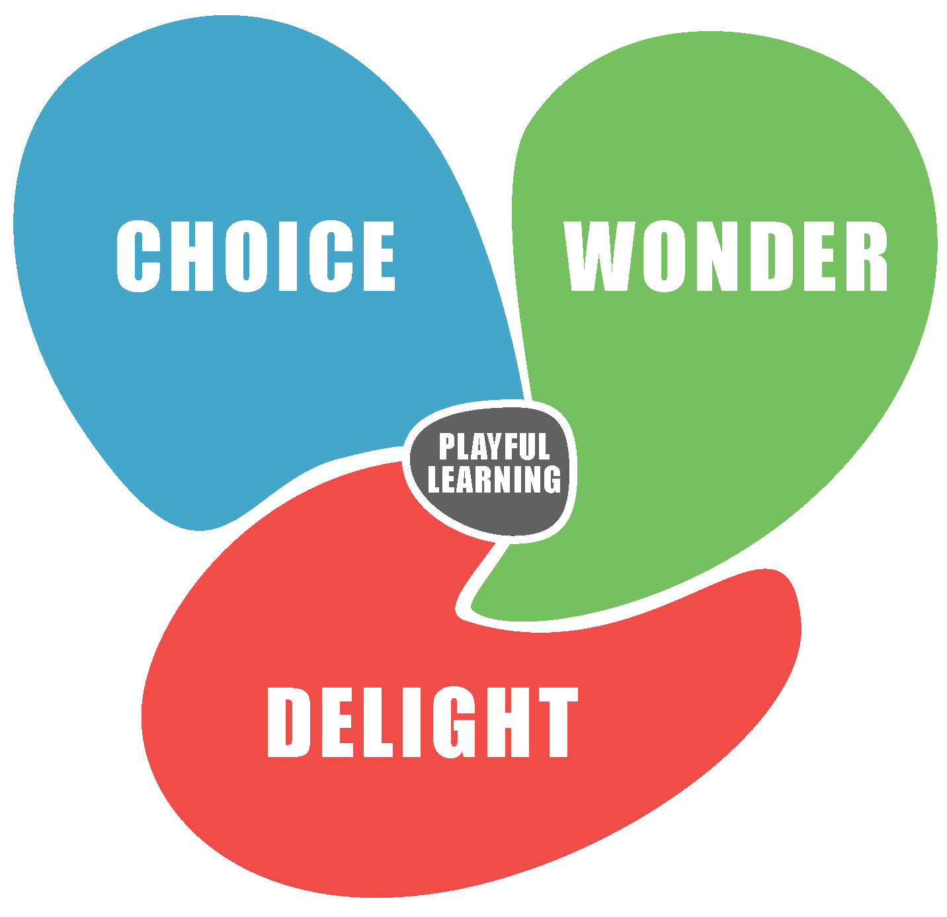
Identify an experience in which you would like to incorporate playful learning (you might think of a particular class, a theme, a unit of learning, a staff meeting, or something else):

How might you structure the experience to encourage…

Choice: a feeling of empowerment, autonomy, ownership, and intrinsic motivation. Can be promoted by helping learners: participate in setting goals, challenges, and purposes; making and changing rules; negotiating; having and sharing ideas; being spontaneous; choosing how long to work/play; choosing collaborators and roles; and moving around.

Wonder: a feeling of curiosity, surprise, engagement, fascination, novelty, and challenge. Can be promoted by supporting learners in improvising, exploring, learning from mistakes, creating, inventing, pretending, imagining, and taking risks.

Delight: a feeling of enjoyment, excitement, satisfaction, inspiration, pride, and belonging. Can be promoted by creating a sense of anticipation, providing time to explore, teachers showing excitement, highlighting learners’ discoveries, and providing aesthetically engaging materials, stories, and ideas.

